

ASU Professional Development Conference 2024
Workshop Proposal Application

The ASU Commission on the Status of Women invites you to submit a proposal to present at the 17th annual
ASU Professional Development Conference scheduled for Wednesday, October 23rd and
Thursday, October 24th – both days via ZOOM.

The goal of the ASU Professional Development Conference is to provide readily-accessible information, resources, and strategies to help individuals succeed in their current position and in their long-term career.
The conference will be hosted exclusively by the CSW for the entire ASU community.
This is the largest university-provided development conference in the nation – so a great opportunity to share your expertise at a conference of this scale!

If you are interested in presenting, please complete the attached application and submit by August 7th (extended deadline ) to Karen Engler-Weber, Program Director for the Office of the Provost at Karen.Engler@asu.edu. We greatly appreciate your support of this important university event!

Additional notes about proposing sessions:

- The ASU Professional Development Conference offers a variety of exciting variety of workshop sessions covering topics related to career development, workplace skills, leadership training, supervisory training, financial planning, sustainability, diversity and inclusion, work/life balance among many others. We welcome proposals in any of these areas, as well as proposals outside of these categories.

- While the CSW welcomes a wide variety of topics, this year’s conference will once again have a theme focusing on workplace wellness. Utilizing the U.S. Surgeon General’s five essentials for Workplace Mental Health & Wellbeing, we are seeking proposals that may help ASU faculty, staff, students, and their respective units achieve aspects of a healthy workplace culture.

Broad range of topics and sub-topics may include:
- Protection from Harm: Safety & Security. Topics not limited to physical safety but other forms of security as well, such as having protections and strategies for dealing with conflict, workplace bullying etc.
- Community & Connection: Social Support & Belonging. Some examples might include how to create a community of support in the workplace, how to network, building team culture, inclusion, diversity, supporting the principles of ASU’s Charter
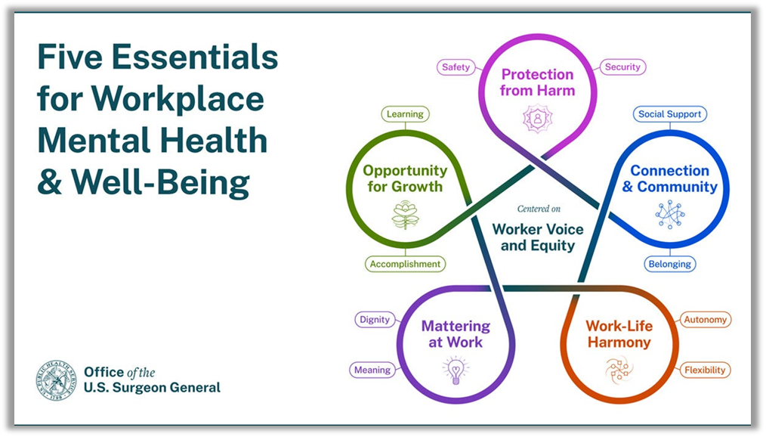

- Mattering at Work: Dignity & Impact

- Opportunity for Growth: Learning & Accomplishments

- Work-Life Harmony: Autonomy & Flexibility

ASU Professional Development Conference 2024
Workshop Proposal Application

Presenter Information
Name:
Position/Title:
Department/Unit:
College:
Email Address:
Primary ASU Affiliation
(Faculty, Staff, Grad Student)

Presenter Experience
Have you presented at the CSW/ASU Conference before If so when?
Do you have previous experience presenting or teaching workshops, classes or presentations? (Y/N)
Do you have experience presenting via Zoom?

If you do have previous workshop experience, please list some of the different presentations you have delivered in the past three years and the audience sizes for those presentations?
Please note any sessions that were presented remotely/via zoom

Workshop Proposal
(If submitting multiple workshop proposals, please copy and paste the workshop details box for each entry.)
What is the title of the session you would like to present?
If your proposal falls under one of the Five Essentials for Workplace Mental Health & Well-Being, what category would you classify it under:
- Protection from Harm: Safety and/or Security
- Connection & Community: Social Support and/or Belonging
- Opportunity for Growth: Learning and/or Accomplishments
- Mattering at Work: Dignity and/or Meaning
- Work-Life Harmony: Autonomy and/Flexibility
Category (can be related, but not a direct fit):

Please provide a description for the workshop session for prospective attendees. This description would be used in the conference schedule/marketing materials.
Please provide a brief outline of what the session will cover:

Additional Questions:
This year’s conference will be hosted via ZOOM.
To help with scheduling, please note your preference below with regards to format and size of your session.

Most workshop sessions are limited to one hour.
Can your session be completed in a one-hour time block?
If you need longer time, please note the time you would need.

ZOOM Set-Up & Hosting:
Would you be comfortable setting up & hosting the ZOOM on your account.
(The CSW would provide some instructions/guidance) or would you prefer the CSW to create & host the ZOOM.

ZOOM Presentation: Audience Size
In the event that the session is hosted via ZOOM, what is the maximum number of attendees you would feel comfortable with presenting to via Zoom?

ZOOM Presentation: Break-Out Rooms
Do you anticipate utilizing break-out rooms for the session?

Costs/Materials for Workshop Sessions
Are there any costs associated with your workshop presentation such as special materials/items?

Presenter Availability:
Please provide your availability and time preference to present on Wed, October 23rd and Thurs, October 24th.
(If you are available for all time blocks, you can note that instead)

Would you be interested in presenting your workshop(s) on both days (either as repeat or spreading your presentations across both days):

Wednesday, October 23, 2024
Presentation Blocks | ZOOM ONLY
8:30AM-9:30AM

9:45AM-10:45AM

11:00AM-Noon

12:15PM-1:15PM

1:30PM-2:30PM

2:45PM-3:45PM

AVAILABLE ALL TIME BLOCKS

Thursday, October 24, 2024
Presentation Blocks | ZOOM Only
8:30AM-9:30AM

9:45AM-10:45AM

11:00AM-Noon

12:15PM-1:15PM

1:30PM-2:30PM

AVAILABLE ALL TIME BLOCKS

Please note any additional information that you would like the CSW Office to take into consideration in scheduling your session:

Please complete the attached form and submit it by August 7th (extended deadline) to Karen Engler-Weber, Program Director for the Office of the Provost at Karen.Engler@asu.edu.
We greatly appreciate your support of this important university event!

